** Department of Electrical and Computer Engineering, NSU**

**CSE 115L: Fundamentals of Computer Programming (Section 4)**

**Lab 04 ( Functions) Faculty: Rsl**

**Functions are useful in writing code once and reusing it again and again without duplicating the code multiple times.**

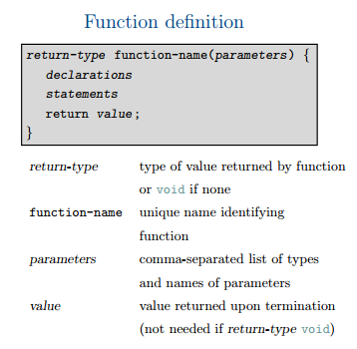

|  |
| --- |
| Ex-1 ( a void function with no input arguments ) |
| #include<stdio.h>  void display();// function prototype  //or function declaration  int main(){  display();  return 0;  }  void display(){// function defination  printf("Inside Display Function!\n");  } |

|  |  |
| --- | --- |
| #include<stdio.h>  //double average (double a, double b);  int main()  {  double no1,no2,result;  printf("Enter 1st number:");  scanf("%lf",&no1);  printf("Enter 2nd number:");  scanf("%lf",&no2);  result= average(no1,no2);  printf("The average is: %f ", result);  return 0;  } | double average(double a, double b){  double ans;  ans= (a+b)/2 ;  return ans;  } |

|  |
| --- |
| Ex-3 ( a function with one input argument that returns a value) |
| #include<stdio.h>  int squareNum(int no);  int main()  {  int x;  printf("Enter a Number:");  scanf("%d",&x);  int ans= squareNum(x);  printf("Squared Answer: %d \n",ans);  return 0;  }  int squareNum(int no){  return no*no;  } |